

|  |
| --- |
| **Mongo DB**  Mini-Project 2  CIS8045  Unstructured Data Management  Master’s in Information Systems Fall 2018  Georgia State University |

Rahul Sharma

Shruthi Jabshetty

Shrikant Patel

Deepali Pareek

Anubhav Pradhan

**Purpose1:**

Screenshots confirming successful installation of MongoDB

Member1 – Deepali Pareek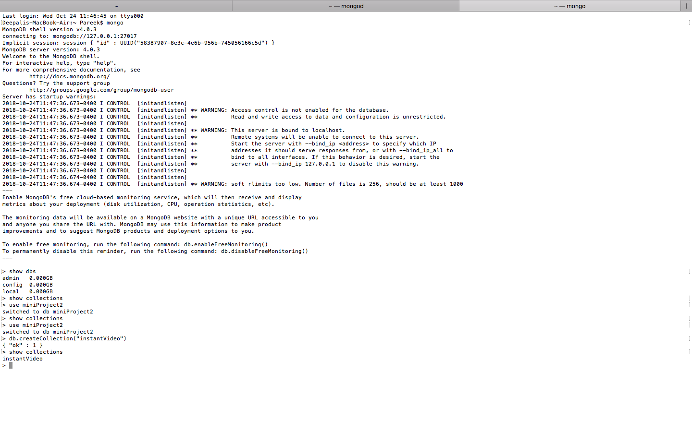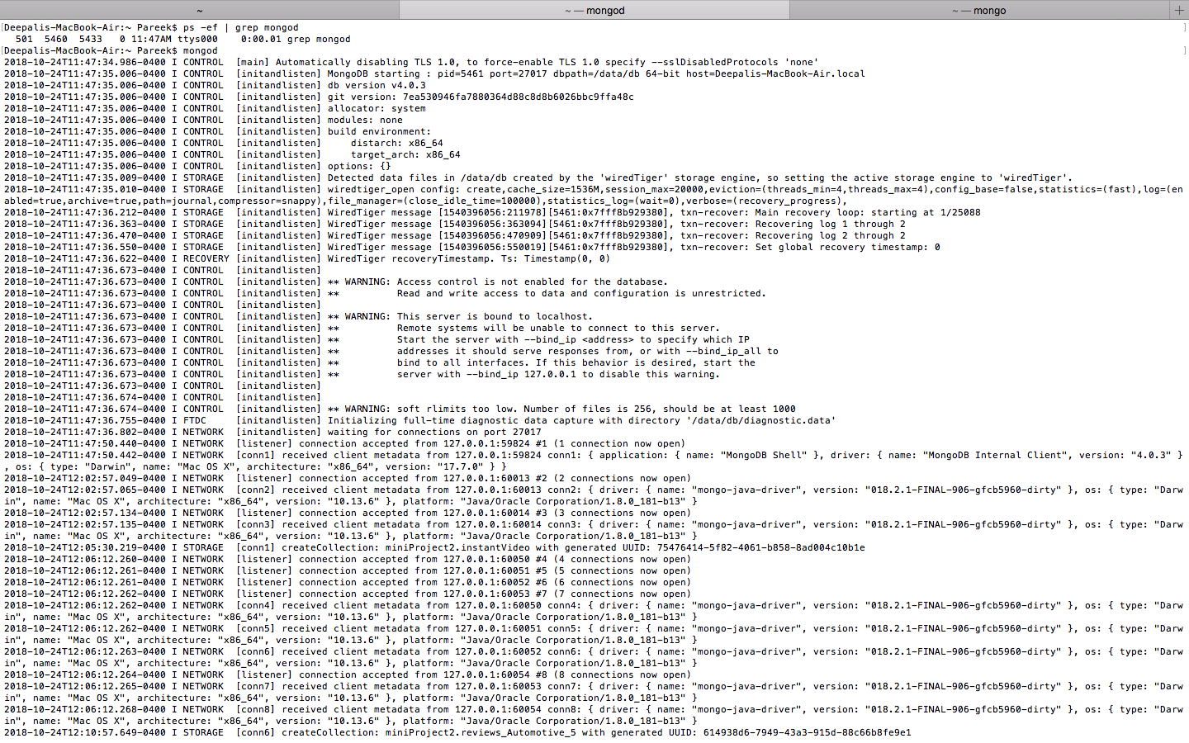

Member 2 – Rahul Sharma



Member3 – Shrikant Patel



Member 4 – Anubhav Pradhan

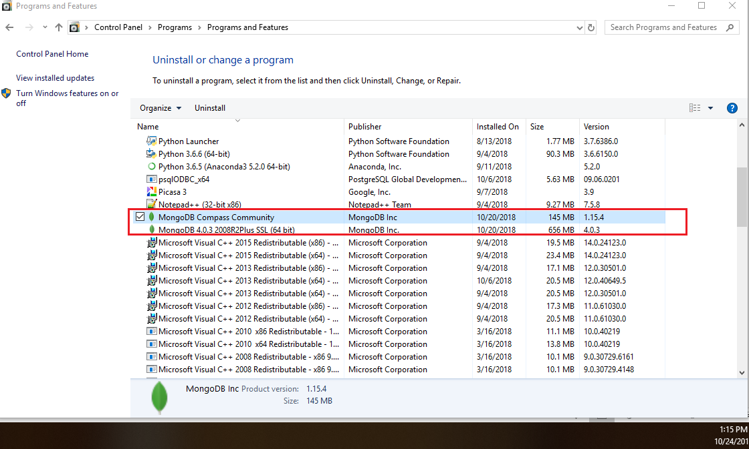

Member 5 – Shruthi Jabshetty

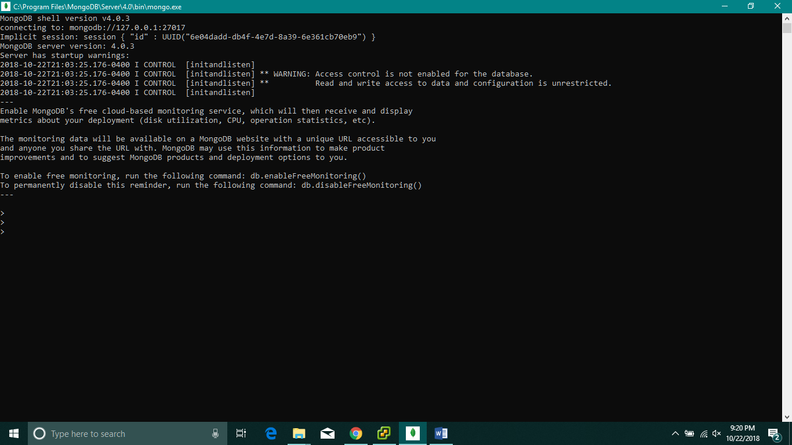

**Purpose 2:**

**Part 2a:**

**Entity Relationship Diagram for Amazon Review System**

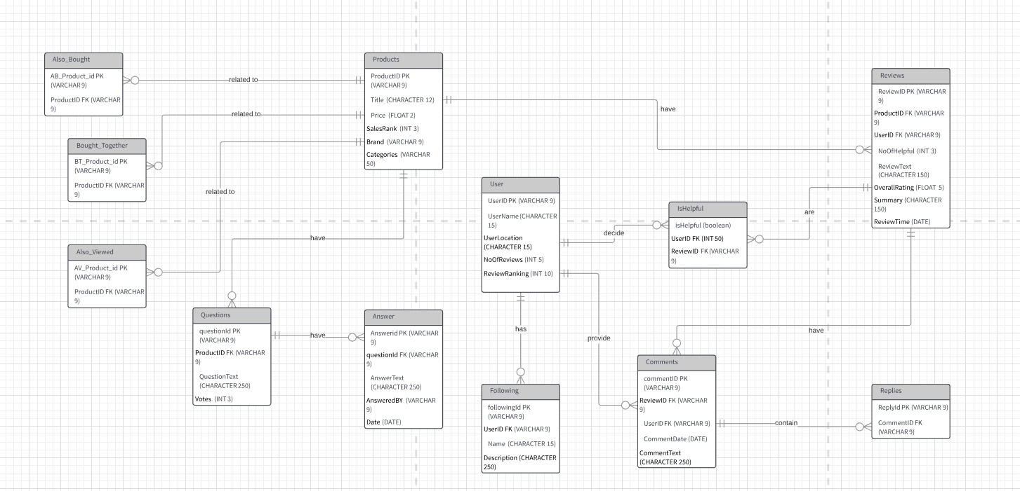

**Business rules:**

1. A Product can have zero or multiple recommendations as Also_Bought product (it is a type of product), and the recommended Also_Bought products will be populated based on the selected product.
2. A Product can have zero or multiple recommendations as Bought_Together product (it is a type of product), and the recommended Bought_Together products will be populated based on the selected product.
3. A Product can have zero or multiple recommendations as Also_Viewed product (it is a type of product), and the recommended Also_Viewed products will be populated based on the selected product.
4. A single product can have zero or many questions.
5. One question can have zero or many answers.
6. A single product can have zero or many reviews.
7. A user can vote zero or many reviews as IsHelpful, and IsHelpful vote will belong to that particular logged in user.
8. A single review can have zero or many IsHelpful votes.
9. A single user can follow zero or more users.
10. A single user can provide zero or multiple comments for a review.
11. A single review can have zero or many comments.
12. A single comment can have zero or many Replies from zero or many users.

**Data Type and Constraints:**

|  |  |  |  |  |
| --- | --- | --- | --- | --- |
| **Sl. No.** | **Table Name** | **Attributes** | **Data Type** | **Constraints** |
| 1 | Product | ProductId | String | Not Null, Primary key |
| Title | String | Not Null |
| Price | Float | Not Null |
| SalesRank | Integer | Not Null |
| Brand | String | Not Null |
| Categories | String | Not Null |
| 2 | Questions | QuestionId | String | Not Null, Primary key |
| ProductId | String | Not Null, Foreign key |
| QuestionText | String | Not Null |
| Votes | Integer | Not Null |
| 3 | Answer | AnswerId | String | Not Null, Primary key |
| QuestionId | String | Not Null, Foreign key |
| AnswerText | String | Not Null |
| AnsweredBy | String | Not Null |
| Date | Date | Not Null |
| 4 | User | UserId | String | Not Null, Primary key |
| UserName | String | Not Null |
| UserLocation | String | Not Null |
| NumberOfReviews | Integer | Not Null |
| ReviewRanking | Integer | Not Null |
| 5 | Following | FollowingId | String | Not Null, Primary key |
| UserId | String | Not Null, Foreign key |
| Name | String | Not Null |
| Description | String | Not Null |
| 6 | Comments | CommentId | String | Not Null, Primary key |
| ReviewId | String | Not Null, Foreign key |
| UserId | String | Not Null, Foreign key |
| CommentDate | Date | Not Null |
| CommentText | String | Not Null |
| 7 | Reviews | ReviewId | String | Not Null, Primary key |
| ProductId | String | Not Null, Foreign key |
| UserId | String | Not Null, Foreign key |
| NumberOfHelpful | Integer | Not Null |
| ReviewText | String | Not Null |
| OverallRating | Float | Not Null |
| Summary | String | Not Null |
| ReviewTime | Date | Not Null |
| 8 | isHelpful | isHelpfulId | String | Not Null, Primary key |
| ReviewId | String | Not Null, Foreign key |
| UserId | Integer | Not Null, Foreign key |
| isHelpful | Boolean | Not Null |
| 9 | Replies | ReplyId | String | Not Null, Primary key |
| CommentId | String | Not Null, Foreign key |
| 10 | Also_Bought | AB_Product_Id | String | Not Null, Primary key |
| ProductId | String | Not Null, Foreign key |
| 11 | Bought_Together | BT_Product_Id | String | Not Null, Primary key |
| ProductId | String | Not Null, Foreign key |
| 12 | Also_Viewed | AV_Product_Id | String | Not Null, Primary key |
| ProductId | String | Not Null, Foreign key |

**Part 2b:**

**Databases:** Create a database “mini_project2”.

**Collections**: Create the collections User and Product.

**Referenced Collections**: Referenced collections are used to represent Many-to-Many Relationship from ER diagram. We have reduced Many-to-Many Relationship to one-to-many by adding a relationship attribute.

**Embedded Collections:** Embedded Collections are used to represent one-to-one and one-to-many relationships from the ER diagram. We have the following embedded collections:

* ‘Reviews’ has ‘IsHelpful’ and ‘Comments’, which in turn has ‘Replies’, ‘Also_Bought’, ‘Also_Viewed’, ‘Bought_Together’, ‘Questions’ has ‘Answers’, ‘User’ has ‘Following’
* isHelpful, Comments in the Reviews.

**Constraints**: We can use Validator to apply schema validation on the collections and apply constraints on the data inserted like

* type (data type constraint) - bsonType
* length – minimum, maximum – integer

minLength, maxLength – String

* pattern – regular expression to verify the email address etc. as below:

“pattern”: “^([a-zA-Z0-9_\-\.]+)@([a-zA-Z0-9_\-\.]+)\.([a-zA-Z]{2,5})$”

* description – to display error message if invalid input is inserted.
* Enum – to apply value constraint like categories as below:

enum : [‘Books’, ‘Luxery’,’high end’, ‘low end’….]

**Constraint Example:** We have applied pseudo mongoDB schema validator for User collection:

db.createCollection(“user”,{

validator:{

$jsonSchema: {

bsonType: “object”,

required: [‘UserName’, ‘UserLocation’,‘NumberofReviews’,’ReviewRanking’,’Following.name’, ’Following.description’] ,

properties: {

UserName:{

bsonType: ’string’,

description: ‘must be a string and required’

},

UserLocation:{

bsonType: ’string’,

description: ‘must be a string and required’

},

NumberofReviews:{

bsonType: ‘int’,

description: ‘must be a int and required’

},

ReviewRanking:{

bsonType: ‘int’,

minimum: 0,

description: ‘must be a int and required’

},

Following.name:{

bsonType: ’string’,

description: ‘must be a int and required’

},

Following. description:{

bsonType: ’string’,

‘minLength’: 0,

‘maxLength’: 500

description: ‘must be a int and required’

},

}

**Indexes:** Indexes help in finding a document details from a collection in a efficient way. We have included the following indexes in our collections.

* Default _id: Primary key from the tables in ER diagram will be unique, we have applied the default _id index on this attribute.
* Text Index: Text index can be applied to the Product.title which will help in easy search of products based on the title search.

db.product.createIndex({title: “text”})

* Single field Index: Single field index can be applied on the Review.ReviewTime to find the reviews based on the review date as below:

db.review.createIndex({‘reviewTime’: 1})

**MongoDB Schema:**

**Product**

{

_Id: 5451221,

title: “Luxury product”,

Price: 78,

Salesrank: 8,

brand: “Pepe Jeans Co.”,

categories: Apparels,

**Reviews**:

[{

_id:102131,

No_of_helpful: 12,

ReviewText: “Love it!!!!! I plan to order more in more colors. Love the adjustable fit. “,

OverallRating: 4,

Summary: “Pepe True Religion Men’s double puff Tshirt”,

Reviewtime August 20, 2016,

**Ishelpful:**

[{

_id: 1900019,

Ishelpful: True

}],

**Comments:**

[{

_id: 0787878,

CommentText: “I ordered two same sized tee shirts. One was the authentic True Religion. The other was a cheap copy. Fake label sewn on over the old. Weird little loop on the sleeve. Sleeves shorter and the length was also shorter than the original. Obviously no one is in charge of quality control so you have a 50-50 shot at getting the authentic True Religion product you are paying for.” ,

CommentDate: March 9, 2017,

**Replies:**

[{

_id: 2011120

}]

}]

}],

**Also_Bought**:

[{

_id:8787992

}],

**Also_Viewed**:

[{

_id:786782

}],

**Bought_Together**:

[{

_id:109012

}],

**Questions:**

[{

_id:800001,

QuestionText: “Is this real Pepe True Religion and can I see the tag?”,

Votes: 23,

**Answer: [{**

_id: 900021,

AnswerText: “Yes, purchased for my grandson it is TR”,

AnsweredBy: Cathy Hazelwood,

Date: August 28,2016

},

{

_id: 900021

AnswerText: “Yes, purchased for my grandson it is TR”

AnsweredBy: “Cathy Hazelwood”,

Date: August 28,2016

}]

}]

}

**User:**

[{

_id:7676001,

UserName: “Mark Jason”,

UserLocation: “Atlanta”,

NumberofReviews: 13,

ReviewRanking: 011,

**Following:**

[{

FollowingId**:** 65656001

name: “John Twinson”

description: “Author”

}]

}]

**Part 2c:**

**Schema Modification**: Schema modification to account for the daily change in product prices for storing information over the year.

1. The TTL index can be used to store the data for a certain amount of time. Documents are removed automatically after specified period of time.

Considering that we have a time of one year, we can create a TTL index as follows:

db.product.createIndex( { "createdAt": 1 }, { expireAfterSeconds: 31536000 } )

This index created in collection ‘products’ would expire after 31536000 seconds after “createdAt”

To add this TTL index to our products table-

db.products.insert( {

"createdAt": new Date (),

"logEvent": 1,

"oldPrice": 100

"oldPrice": 105

} )

2. Other way of storing the data of a particular length is “capped collections”. Capped collection are fixed size collections that support high throughput data. Here insertion order is important as the insertion and retrieval is in order and the queries do not need index to return the document in insertion order.

A capped collection can be created while creating the ‘products’ collection by setting ‘capped’ : true and specifying the size of the collection as 365.

The collection can be created as-

db.createCollection(Product, { capped: true,

autoIndexId: true,

size: 365,

Product_ID: 1111,

.

.

. .} )

**Purpose3: Images for Mongo DB Imports**

Member 1 – Anubhav Pradhan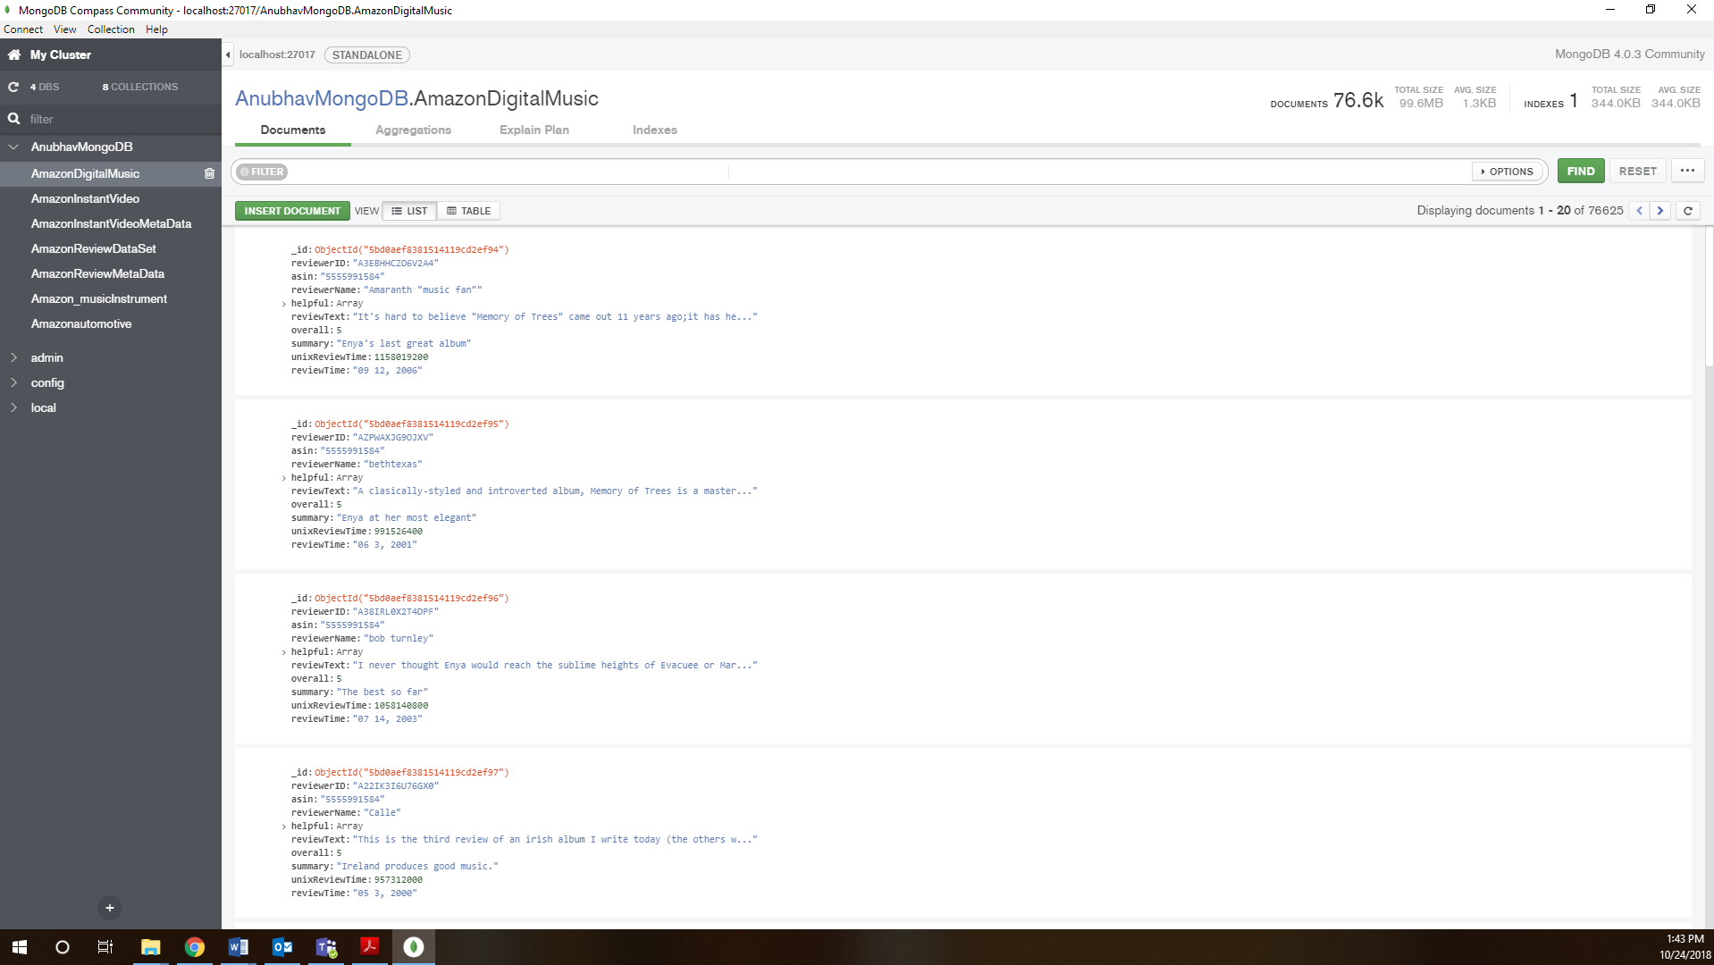

Member 2 – Rahul Sharma 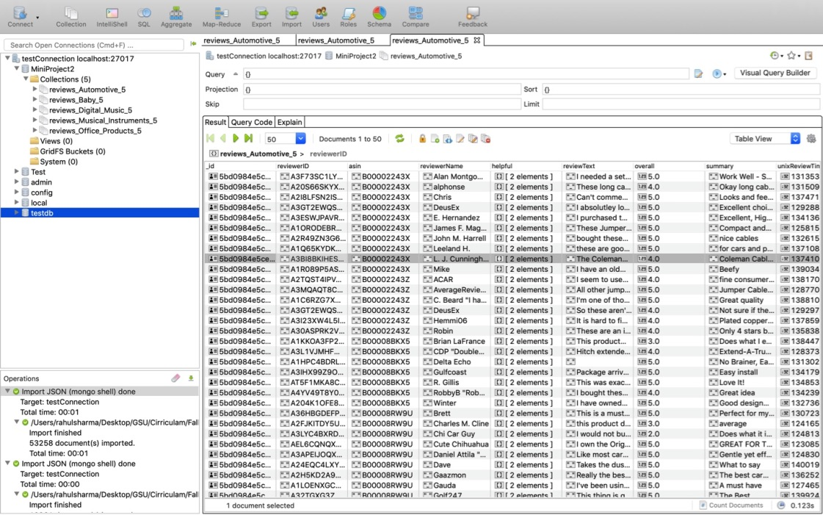

Member 3 – Shrikant Patel

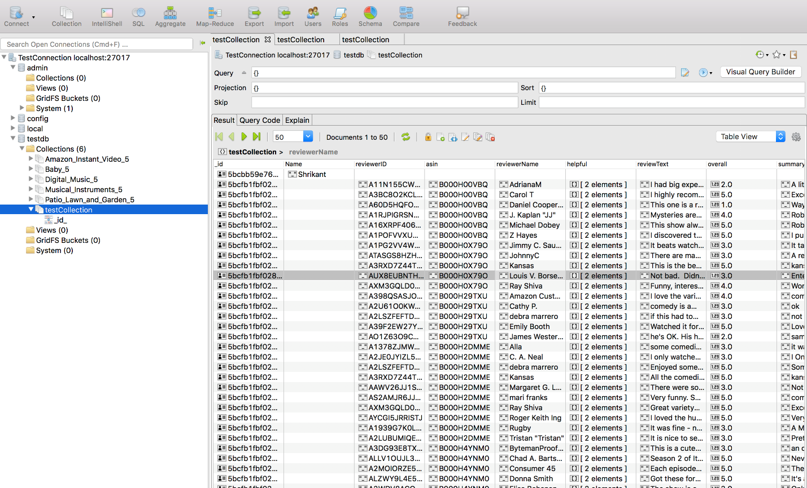

Member 4 – Deepali pareek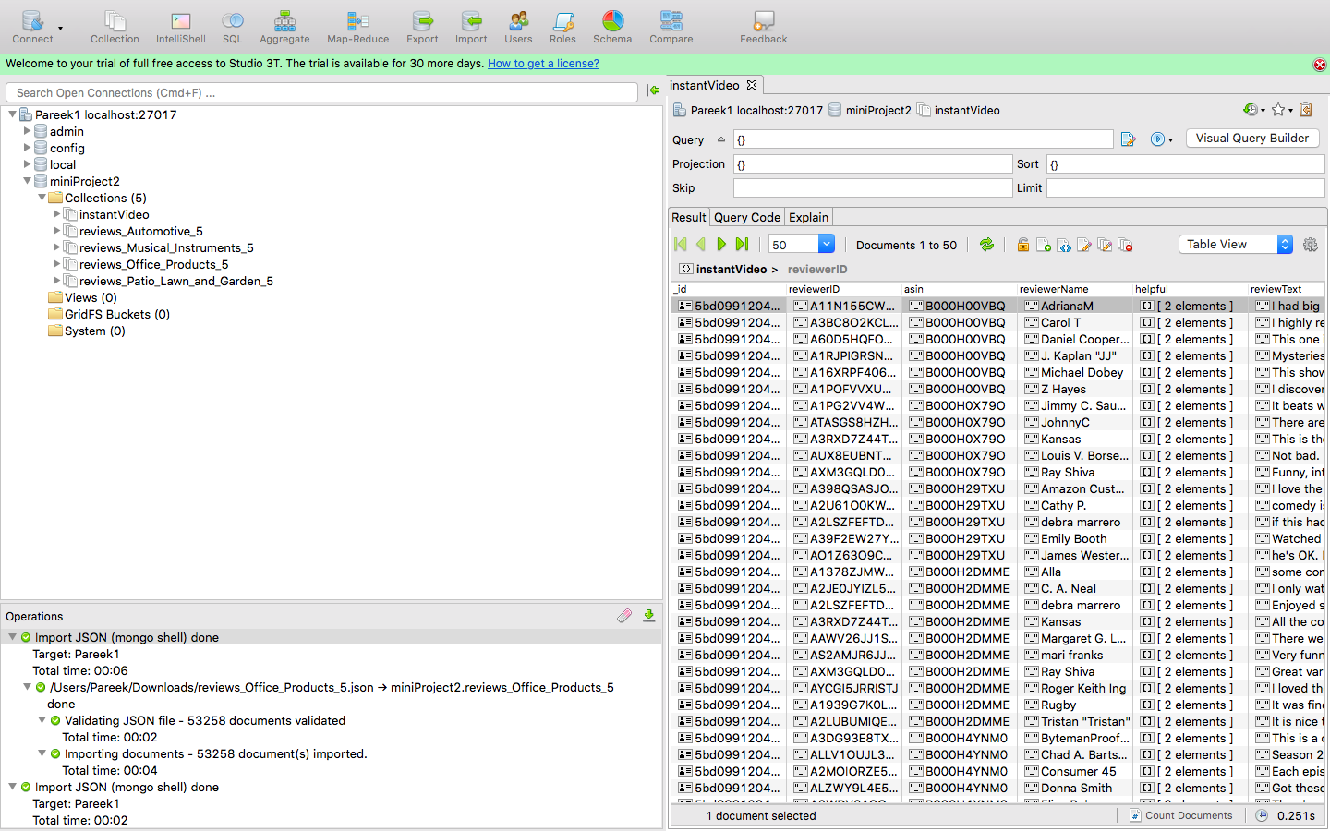

Member 5 – Shruthi Jabshetty

